Website Content Extraction (Word-for-Word)

Website Content Extraction (Word-for-Word)

This document contains the exact wording extracted from the website's source code, organized by section.

----------------------------------------------------

1. Top Navigation Bar
- - Links: Home, Curriculum, Join, FAQ

----------------------------------------------------

2. Hero Section
- - Label: INSTITUTIONAL-GRADE TRADING EDUCATION
Updated Content (INSTITUTIONAL-STYLE ALGO TRADING PROGRAM)
- - Heading: Master the Markets with Professional Precision
Updated Content (Eliminate Emotional Bias. Learn to Trade Like Institutions. Execute Like an Algorithm.)
- - Description: Learn the high-stakes strategies used by institutional desk traders. Join an elite ecosystem focused on risk management, technical mastery, and psychological edge.
Updated Content (Discover a structured trading framework that blends institutional market knowledge with algorithmic strategies, enabling disciplined execution, effective risk management, and long-term consistency.)
- - Buttons: Get Instant Access, View Curriculum
Updated Content (Get Started/Enroll now), (View Course Modules)
- - Social Proof: 500+ TRADERS ENROLLED WORLDWID
Updated Content (250+ TRADERS TRAINED WORLDWIDE)

----------------------------------------------------

3. Curriculum Overview Section
- - Label: CURRICULUM OVERVIEW
- - Heading: A Comprehensive Roadmap to Mastery
- - Description: 11 specialized modules designed to take you from market basics to building your own AI-powered trading systems.
- - Modules:
- 01: Indian Market Infrastructure & Trader Mindset
- Master the fundamentals of Indian market operations, including NSE/BSE dynamics, SEBI regulations, and settlement cycles.
- Understand market participants, build a robust trader mindset, and calculate your trading edge using probability and VIX.
- 02: Technical Analysis: Reading the Language of Price
- Learn to decode price action using candlestick anatomy, trendlines, and key support & resistance levels.
- Identify high-probability continuation and reversal chart patterns, and validate your setups using volume analysis.
- 03: Market Structure, Price Action & Context
- Navigate market phases (Trend, Range, Transition) and track institutional accumulation and distribution.
- Master valid breakout criteria, multiple timeframe confirmation, and learn to avoid retail stop-hunts.
- 04: Basics of Python for Traders
- Set up your Python environment from scratch with a focus on trading applications.
- Learn essential programming constructs including loops, dictionaries, functions, and data handling.
- 05: AI as Your Trading Co-Pilot
- Integrate AI tools like ChatGPT, Claude, and Perplexity for real-time market research and code generation.
- Master prompt engineering to effectively stress-test strategy logic, review journals, and analyze data.
- 06: No-Code Strategy Building with TradingView & AI
- Leverage AI to write, debug, and verify Pine Script v5 logic without prior coding experience.
- Interpret strategy tester metrics (Net Profit, Max Drawdown) and avoid common strategy exclusions.
- 07: Python for Traders - AI Does the Heavy Lifting
- Use AI to code indicators and handle Indian market data via yFinance while avoiding look-ahead bias.
- Master data quality management, prevent duplicate entries, and set up a reliable paper trading log.
- 08: Backtesting, Metrics & Quant Modeling
- Understand the reality of backtesting, overfitting, and walk-forward testing across different market regimes.
- Use AI to brainstorm, build, and optimize quantitative models including Monte Carlo simulations.
- 09: Live Broker API, Safety Controls & SEBI Compliance
- Master API fundamentals, rate limits, and order types using Zerodha KiteConnect and 5paisa.
- Implement strict safety controls and ensure compliance with SEBI's algorithmic trading routing requirements.
- 10: Trading Psychology & Institutional Trading Methods
- Develop an institutional mindset, understand options mechanics (theta decay, IV crush), and track smart money.
- Build a disciplined pre-trading routine encompassing VIX analysis, news tracking, and max loss rules.
- 11: Building Code Together
- Collaborate to create and deploy fully functional algorithmic strategies of your choice.
- Adapt and launch your customized trading algorithms across diverse instruments (Crypto, Stocks, Forex).
UPDATED CONTENT (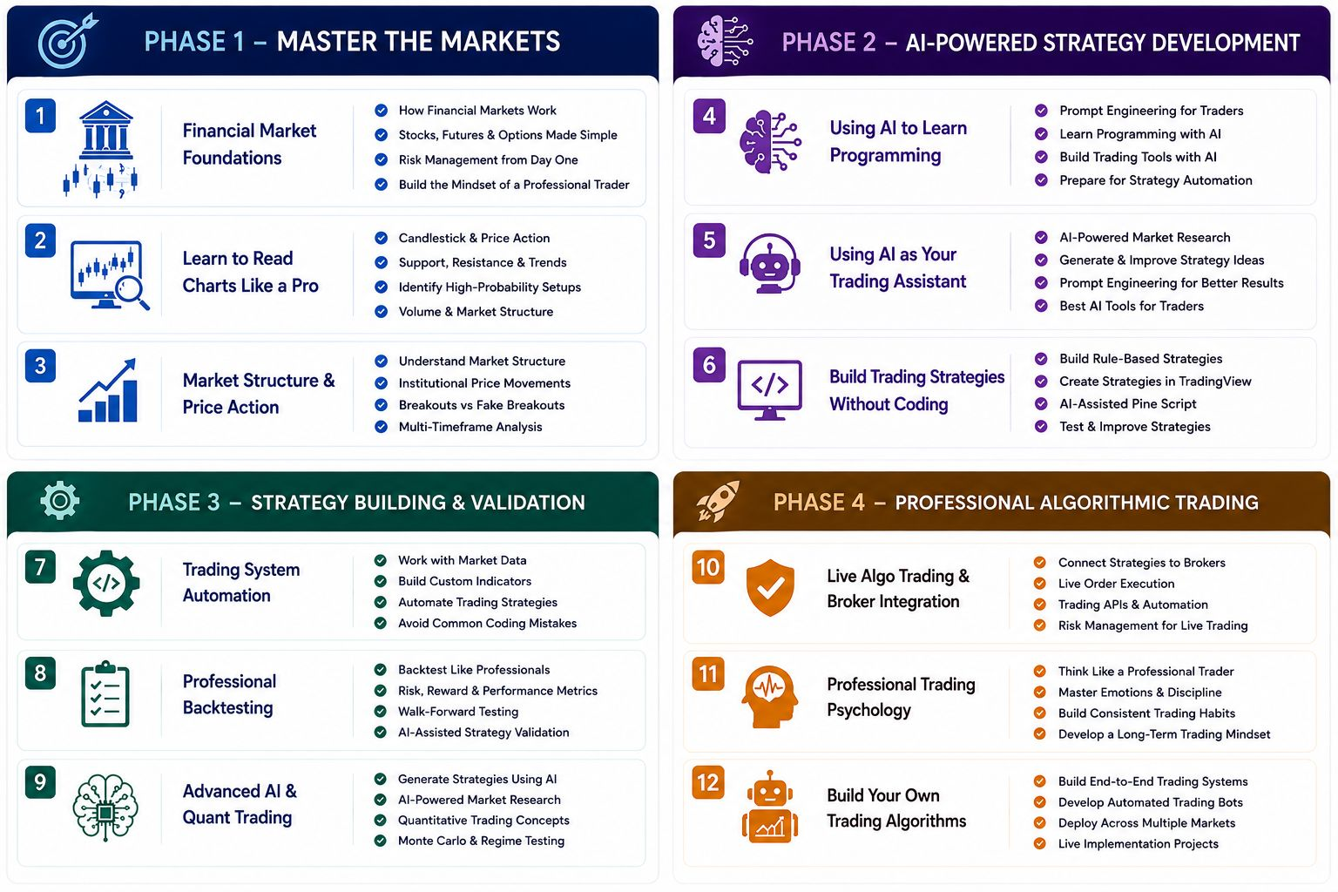

----------------------------------------------------

4. Team Section
- - Nitya (Trader & Mentor)
- - Shwetaly (Trader & Mentor)

----------------------------------------------------

5. Registration Section (Join Program)
- - Heading: Secure Your Spot
- - Description: Spaces for our next session are strictly limited. Complete this short application to ensure this bootcamp is the right fit for you.
- - Bullet Points:
- Lifetime access to course materials
- Exclusive Discord community access
- Weekly live market recap calls
UPDATED CONTENT (REMOVE THIS)

Form Questions & Steps:
- - 1. Basic Details
- FULL NAME (Placeholder: John Doe)
- WHATSAPP NUMBER (Placeholder: +91 98765 43210)
- EMAIL ADDRESS (Placeholder: john@example.com)
- CITY & COUNTRY (Placeholder: Mumbai, India)
- - 2. Trading Background
- How long have you been trading? (Options: Beginner, Less than 1 year, 1–3 years, More than 3 years)
- What best describes your trading style? (Options: Scalping, Intraday, Swing Trading, Positional, Long-term Investing, I haven't developed a strategy yet)
- - 3. Readiness & Challenges
- What is your current experience with Algo Trading? (Options: Never tried it, Watched videos only, Built simple strategies, Already running live algos)
- What is your biggest challenge in trading? (Choose one) (Options: Emotional trading, Lack of consistency, Risk management, Coding algorithms, Backtesting, Strategy execution, Time management)
- - 4. Your Goals
- Why do you want to join this bootcamp? (Options: Build my first trading bot, Automate my existing strategy, Become a full-time trader, Remove emotions from trading, Learn Pine Script, Learn professional backtesting)
- Approximately how much capital do you currently trade with? (Options: Not trading yet, Under ₹50,000, ₹50k–₹2L, ₹2L–₹10L, Above ₹10L)
- - 5. Final Thoughts
- Have you ever purchased any trading course before? (Options: Yes, No)
- What was missing from that course? (Placeholder: Share your thoughts...)
- What outcome would make this bootcamp a huge success for you? (Placeholder: Describe your ideal outcome...)
- - Buttons: Next, Back, Submit Application
- - Success Message:
- Heading: Application Received!
- Description: Thank you for applying. Our team will review your application and get back to you shortly via email or WhatsApp.

----------------------------------------------------

6. Frequently Asked Questions (FAQ) Section
- - Heading: Frequently Asked Questions
- - Description: Everything you need to know before starting your journey.

Questions and Answers:
- - Q: How is this course helpful for me?
A: This bootcamp is designed to help you build your own complete algorithmic trading system from scratch. By the end of the program, you will be able to create, test, optimize, and deploy trading strategies independently without relying on external support, signals, or paid strategy providers.
- - Q: Do I need prior coding experience to join this course?
A: No. This course is designed for beginners as well as experienced traders. We will teach you how to leverage AI tools to assist with coding, making the learning process much simpler. The curriculum starts from the basics and gradually progresses to advanced concepts.
- - Q: Do I need prior trading experience?
A: No prior trading experience is required. We will cover the essential trading concepts needed to understand algorithmic trading before moving into strategy development and automation.
- - Q: What software and tools will I need?
A: All required tools, libraries, and software setup will be guided by our team. We will help you install and configure everything needed so you can focus on learning rather than dealing with technical issues.
- - Q: Will I be able to build my own trading strategies?
A: Yes. The primary goal of the bootcamp is to help you develop, backtest, optimize, and automate your own trading strategies based on your trading style and objectives.
- - Q: Is algorithmic trading only for programmers?
A: Not anymore. With modern AI tools and the structured approach taught in this bootcamp, even non-programmers can successfully build and manage algorithmic trading systems.
- - Q: Will I receive support during the course?
A: Absolutely. Our team will provide guidance throughout the bootcamp, helping you with technical setup, strategy development, backtesting, and implementation challenges.
- - Q: What markets can I automate after completing the course?
A: The concepts taught in the bootcamp can be applied across multiple markets, including stocks, indices, commodities, and other financial instruments, depending on broker and platform compatibility.
- - Q: How is this different from a regular trading course?
A: Most trading courses focus on teaching setups and indicators. This bootcamp focuses on helping you build a data-driven, automated trading system that can test ideas objectively and execute trades systematically.
- - Q: Will I get ready-made strategies?
A: The focus of the bootcamp is to teach you the process of creating profitable systems rather than depending on ready-made strategies. This gives you the skills to develop and adapt strategies for years to come.
- - Q: Can I backtest strategies before risking real money?
A: Yes. You will learn how to rigorously backtest strategies using historical data, helping you evaluate performance and build confidence before deploying capital.
- - Q: What happens after the bootcamp ends?
A: You will have the knowledge, tools, and framework needed to continue building, testing, and improving your own algorithmic trading systems independently.
- - Q: How long does it take to become confident in algo trading?
A: This varies from person to person, but by the end of the bootcamp, you will have a structured framework to develop, test, and automate strategies with confidence.
- - Q: Is this course suitable for working professionals?
A: Yes. The bootcamp is designed to be practical and structured, making it suitable for students, working professionals, traders, and business owners who want to build automated trading systems.
- - Q: What is the biggest benefit of learning algorithmic trading?
A: Algorithmic trading removes emotional decision-making and allows you to trade based on data, rules, and statistical evidence, leading to a more disciplined and scalable trading process.

----------------------------------------------------

7. Footer Section
- - Heading: TradeIQ
- - Description: Empowering the next generation of financial professionals with precision and institutional strategies.
UPDATED CONTENT (Empowering traders with institutional-grade education, AI-powered trading systems, and data-driven strategies to build consistency, confidence, and long-term success in the financial markets.)
- - Links - LEARNING PATHWAYS: Price Action & Structure, Python for Algo Trading, AI Co-Pilot Systems, Quantitative Models, Institutional Risk Controls
UPDATED CONTENT ( keep above same but also add
* Strategy Building & Backtesting
* Professional Trading Psychology)
- - Links - SITE MAP: Home, Curriculum, Join Program, FAQ
- - Newsletter - STAY UPDATED: Join our newsletter for weekly market insights.
UPDATED CONTENT (REMOVE THIS)
- Input Placeholder: Email
- Button: JOIN
- Success Message: Successfully subscribed!
UPDATED CONTENT (Bottom Tagline
Institutional Knowledge. AI-Powered Edge. Rule-Based Execution.)
- - Copyright: © 2026 TradeIQ Financial Education. All rights reserved.
UPDATED CONTENT (Optional Trust Badge (Above Copyright)
✔️ Designed for Serious Traders
✔️ AI-Powered Learning
✔️ Institutional Trading Concepts)

